NAME: MUNAZA MUNIR
CONTACT NO: 03220147287
EMAIL: 70146760@student.uol.edu.pk
- Title: Cypress Web Automation Testing Report
- Internship: SQA Internship – Week 03 Task 1
- Submitted By: Munaza Munir
- University: The University of Lahore
- Date: 22 July 2026

Cypress Testing Report

Personal Profile Website Testing Using Cypress

1. Project Title
Automated Testing of Personal Profile Website Using Cypress

2. Objective
The objective of this task was to perform automated testing on a personal profile website using Cypress, a modern JavaScript-based end-to-end testing framework.
The main goals were:
- To learn Cypress installation and setup.
- To create an automated testing environment.
- To test important website functionalities.
- To verify page loading, navigation, and contact form behavior.
- To perform both positive and negative testing.
- To identify possible issues and ensure the website works correctly.

3. Tools and Technologies Used
Tool | Purpose
Visual Studio Code | Writing website and Cypress test files
Node.js | Running Cypress environment
npm | Installing Cypress package
Cypress | Automated end-to-end testing
HTML | Website structure
CSS | Website styling
JavaScript | Website functionality and Cypress tests

4. Initial Requirements
Before installing Cypress, the following software was required:

Node.js Installation
Cypress requires Node.js and npm.
Node.js was downloaded and installed from the official website.
After installation, the installation was verified using:
node -v
and
npm -v
Successful version output confirmed that Node.js and npm were ready.

5. Creating Project Folder
A separate folder was created for Cypress testing.
Example:
Personal-Profile-Testing
This folder contained:
Personal-Profile-Testing
│
├── index.html
├── styles.css
├── script.js
These files represented the personal profile website.

6. Opening Project in VS Code
Steps:
- Open Visual Studio Code.
- Select:
File → Open Folder
- Select:
Personal-Profile-Testing
The complete website files were opened in VS Code.

7. Initializing Node Project
The terminal was opened in VS Code:
Terminal → New Terminal
The following command was executed:
npm init -y
Purpose:
- Created a Node.js project.
- Generated a package.json file.
- Prepared the project for installing Cypress.
After execution, a new file was created:
package.json

8. Installing Cypress
Cypress was installed using npm:
npm install cypress --save-dev
Purpose:
- Downloaded Cypress testing framework.
- Added Cypress as a development dependency.
- Created required Node modules.
After installation, the project contained:
node_modules
package.json
package-lock.json
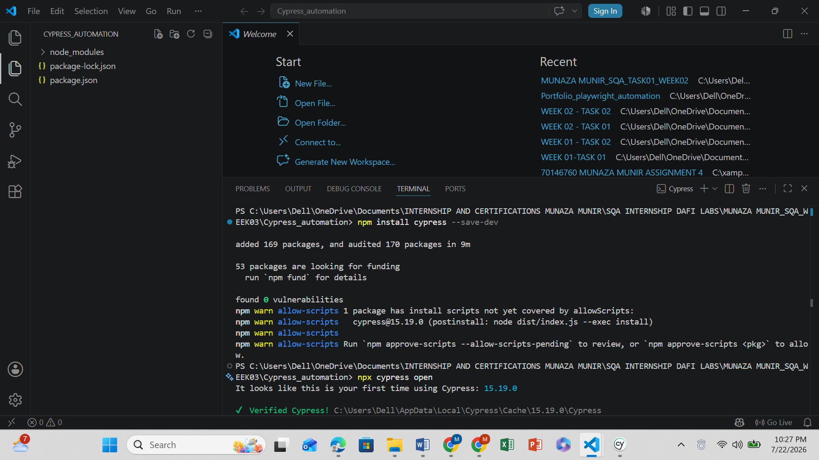

9. Opening Cypress for the First Time
Cypress was launched using:
npx cypress open
The Cypress setup window appeared.
Selected:
E2E Testing
Then:
Continue
Cypress automatically created the required folders.

10. Cypress Folder Structure
After setup, Cypress generated:
cypress
│
├── e2e
│
├── fixtures
│
└── support

e2e Folder
Used for writing test cases.
Example:
cypress/e2e/

fixtures Folder
Used for storing test data.
Example:
cypress/fixtures/
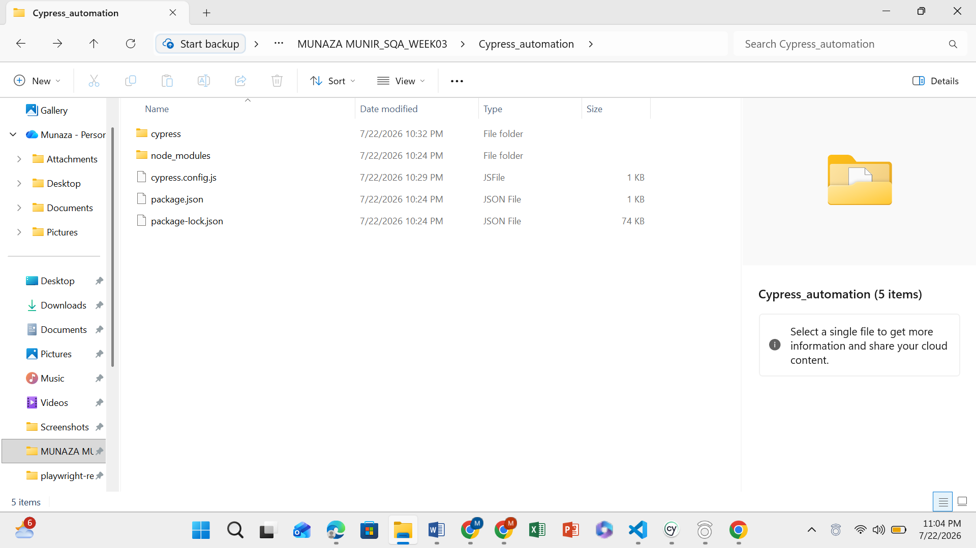

11. Creating Cypress Test Files
Inside:
cypress/e2e
three test files were created:
page_loading.cy.js

navigation.cy.js

contact_form.cy.js
These files contained automated test cases.
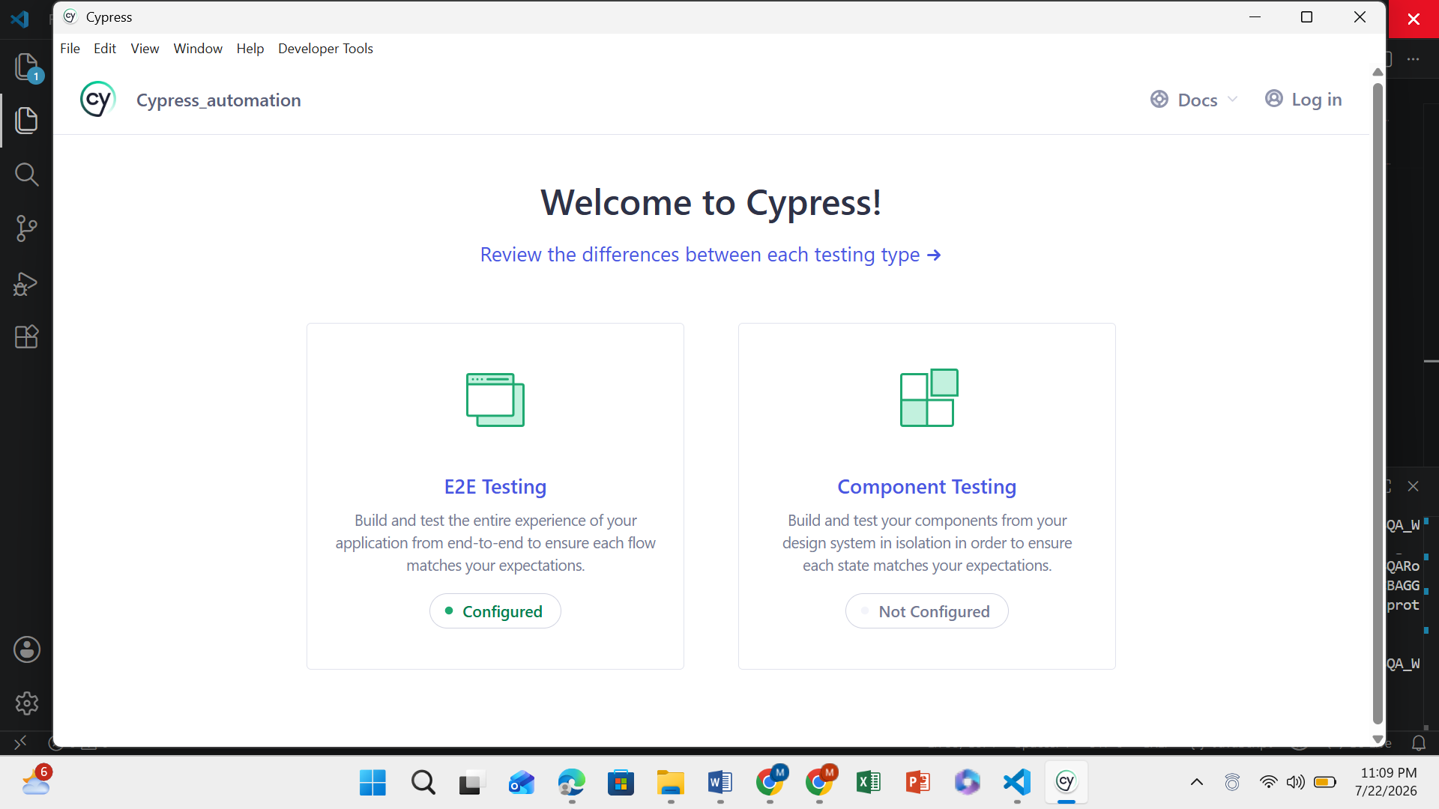

12. Scenario 1: Page Loading Testing

Objective
To verify that the website loads successfully.

Test Performed
Cypress opened the website URL:
cy.visit('http://127.0.0.1:5500/index.html')

Expected Result
Website homepage should open successfully.

Result
PASS ✅
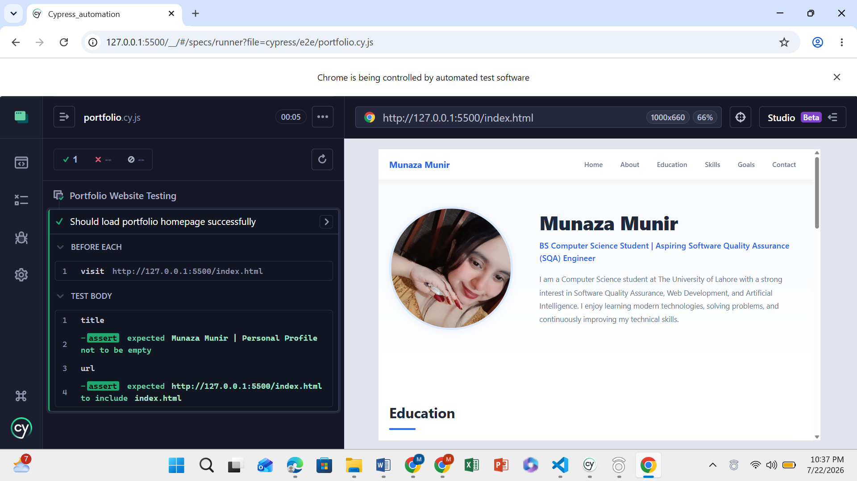

13. Scenario 2: Navigation Testing

Objective
To verify that navigation links work correctly.
The following sections were tested:
- Home
- About
- Education
- Skills
- Goals
- Contact

Testing Method
Cypress clicked navigation links and verified the correct sections.

Result
PASS ✅
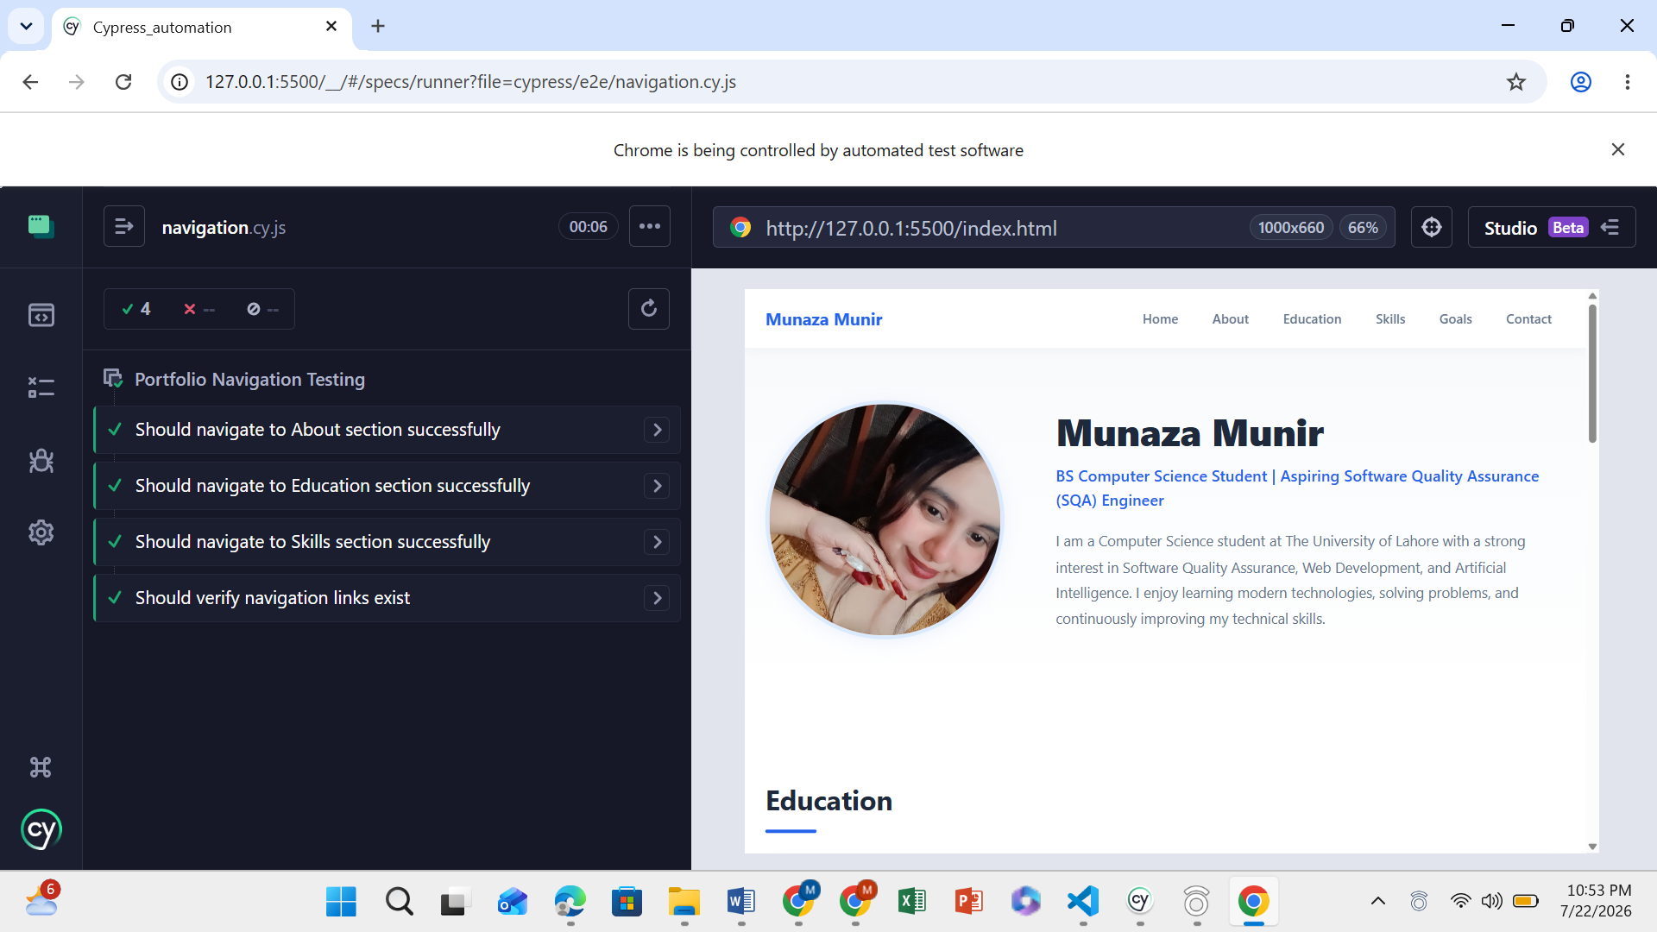

14. Scenario 3: Contact Form Testing

Objective
To test the contact form functionality using:
- Positive testing
- Negative testing

Positive Test Case

Input:
Name:
Munaza Munir
Email:
munaza@gmail.com
Message:
Testing contact form

Expected Result:
Success message should appear.

Result:
PASS ✅

Negative Test Case

Input:
Empty form fields.

Expected Result:
Browser validation should prevent submission.

Result:
PASS ✅
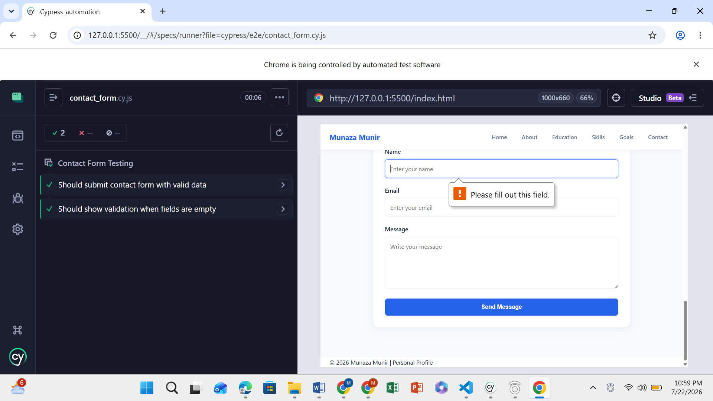

15. Final Cypress Test Result
All scenarios were successfully completed.
Scenario | Status
Page Loading Testing | PASS ✅
Navigation Testing | PASS ✅
Contact Form Positive Testing | PASS ✅
Contact Form Negative Testing | PASS ✅

16. Conclusion
This task provided practical experience with Cypress automation testing. The website was successfully tested through multiple end-to-end scenarios. Cypress helped automate user actions and verify that website features were working correctly. Through this activity, knowledge of test automation, test case creation, validation testing, and software quality assurance practices was improved.

